****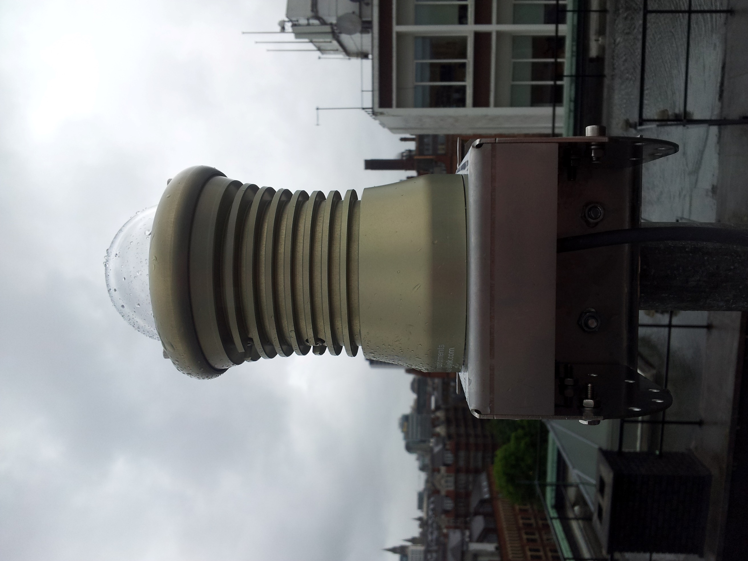

SCAMP

Camera and software setup guide

**Version 1.2, 8th August 2017**

Table of Contents

1. Introduction 3

2. The Hardware 3

2.1 The Hardware – Overview 4

2.2 The Hardware – In more detail 5

3. Installation of the Hardware 6

3.1 The Camera 6

3.2 The Intel Pro Network Card 6

4. Software stage 1 – Getting an image 6

4.1 Installation of Basler Pylon version 3 6

4.2 Getting an image 7

5. Software stage 2 – FreeTure 8

5.1 Obtaining and installing FreeTure for Windows 8

5.2 The FreeTure configuration file 8

5.3 Network Time Protocol software 9

5.4 Creating a Mask file 10

6. Software stage 3 –Autonomous Operation 11

6.1 Batch file for the command line 11

6.2 Auto start-up, and auto-Run of FreeTure 11

6.3 Auto-off 11

6.4 Remote Control Software 11

Appendix 1 – Assembling the Mount 12

Appendix 2 – The Configuration file 14

Appendix 3 – What’s inside the camera enclosure 22

Appendix 4 - Contact 23

# 1. Introduction

**SCAMP** (the **S**ystem for **C**apture of **A**steroid and **M**eteorite **P**aths) is a network of all-sky cameras based in the UK. SCAMP detects and records bright fireballs so that the location of any resulting meteorite fall can be estimated. Any meteorites recovered using SCAMP will be donated to UK museums or universities, along with all images and data recorded.

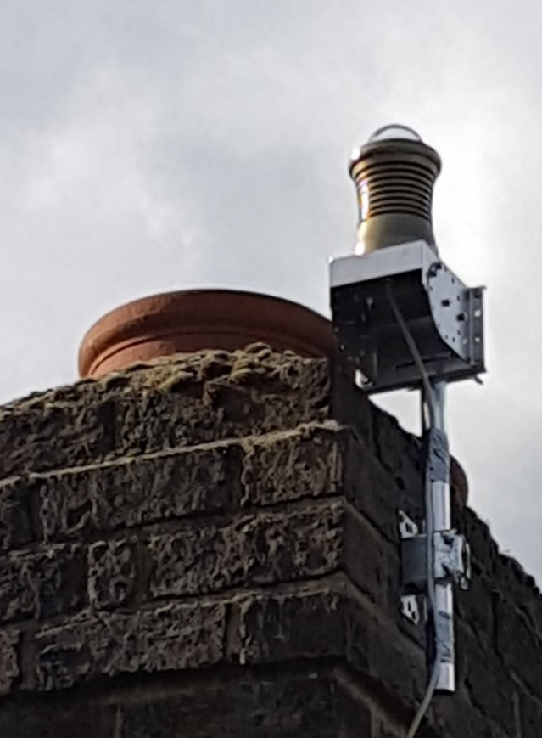SCAMP is very closely based on the French FRIPON network of about 100 cameras; see [www.fripon.org](http://www.fripon.org). FreeTure is the software which was written by the FRIPON project team to operate each camera, and is the software used by SCAMP.

This guide describes how to install a FRIPON/SCAMP camera and its FreeTure software. Some existing help is available at <https://github.com/fripon/freeture/wiki>, and the aim of this guide is to present that information in a systematic way with the gaps filled.

Topics covered include:

* Hardware selection, in addition to the FRIPON camera;
* Hardware setup;
* Software setup, including FreeTure for Windows; and
* Autonomous operation, so you can set up the station then forget it for long periods of time.

To give feedback and suggest improvements, please get in touch - see the last page for details. SCAMP is an initiative of the UK Meteor Observation Network and has its web home at <https://ukmeteornetwork.co.uk/SCAMP/>.

# 2. The Hardware

You’ll need the following:

* A FRIPON camera, obtainable from Shelyak Instruments in Grenoble (<http://www.shelyak.com/?lang=2>).
* A desktop PC running Windows; and
* Various cables and bits and pieces listed in section 2.1 , all of which are easily obtainable from Amazon.

The hardware is listed and illustrated in more detail on the following two pages. If you’re curious about what’s inside the camera enclosure, see Appendix 3, though that’s not essential reading.

## 2.1 The Hardware – Overview





## 2.2 The Hardware – In more detail

The items listed on the previous page are, in more detail:

1. **The FRIPON camera**, supplied by Shelyak Instruments. The camera inside the housing is produced by Basler, and so Basler drivers and software are used for FRIPON/FreeTure. See Appendix 3 for a description of what’s inside the housing.
2. **Mounting bracket** - comes with the camera. See Appendix 1 for assembly instructions.
3. **Further mounting bracket** - to attach the mounting bracket in your chosen location you may need a further bracket. The one shown here is a television aerial mounting bracket purchased from Amazon.
4. **Junction box** – the one sold with the camera is just a waterproof box where the cables can be joined. A double-ended cable socket is also supplied with the camera, to join the cables.
5. **Cable 1.** An ethernet cable is used to power the systems and for data communications. Just one cable is used to do these two things. It must be of GigE spec, i.e. Ethernet Cat 5e, 6 or 7, and no more than one hundred metres long. Make sure cables aren’t in contact with sharp metal edges. Cable obtainable from Amazon.
6. **PoE Injector.** A Power over Internet (PoE) injector is needed. It should be IEEE 802.3af compliant, which means it operates in a controlled voltage range and so won’t damage the camera. Obtainable from Amazon.
7. **Cable 2.**  A second GigE cable, i.e. Ethernet Cat 5e, 6 or 7.
8. **Ethernet card.** The Basler cameras are designed to work best with an Ethernet card incorporating the Intel Pro chipset. Basler have produced a special driver for this chipset that reduces the processing load on the computer and is proven to work with the camera, so for about £30 it seems unwise to use anything else. Buy any Intel Pro ethernet card (e.g. the Intel EXPI9301CTBLK PRO1000 Network Card CT PCIex) with two or more ports (so you have one for an internet cable if needed) and a speed of greater than 1,000 Mbps. Again obtainable from Amazon.
9. **PC.** Your PC should be a desktop model that’s less than five years old and runs Windows. Laptops aren’t suitable as they are not designed for unsupervised operation, and in particular don’t have functionality in the BIOS for automated switch-on at a predetermined time. Good new-ish desktop PCs are available on eBay for £100 to £200.
10. **Mains timer switch.** The Basler camera should be able to run during daylight without damage, but as yet the FRIPON network is only operated at night. A timer switch will save your hardware from being on unnecessarily and also forces a hard reset of the hardware every evening, which means that if it “hangs” then you’ll probably only lose one night’s observations. For the same reason, a mains timer switch on the computer is a good idea.

# 3. Installation of the Hardware

## 3.1 The Camera

Look for the “N” on the base of the camera, and orient this as near to North as possible – it must be within 15 degrees, but the closer the better. Also, make sure the camera base is as close to level as possible. See Appendix 1 for more detailed instructions.

The dome will come with a piece of plastic stuck to it for protection – leave it on as long as possible during camera installation, but also note that it’s mucky so you’ll need to clean the dome after you’ve taken the plastic off, or the glue will show up on your image.

## 3.2 The Intel Pro Network Card

This is an important part of the system and shouldn’t be skipped, or you may not get the data transfer rates and processing capabilities that you need.

Basler have produced the “Basler performance driver”, which is an Intel-specific GigE Vision network driver. According to Basler[1], the advantage of the performance driver is that it “significantly lowers the CPU load needed to service the network traffic between the computer and the camera. It also has a more robust packet resend mechanism”.

So, if you spend £30 on the Intel Pro network card, you can choose a lower-spec computer and are likely to get a better, more stable result overall.

# 4. Software stage 1 – Getting an image

The correct order of events is (a) install the Intel Pro card in your PC, (b) install Basler Pylon as below, then (c) install everything else in any order. If you’ve installed Pylon before installing the Intel Pro card, then uninstall Pylon and start again, or you won’t be using the correct hardware drivers.

## 4.1 Installation of Basler Pylon version 3

“Pylon” is the operating software produced by Basler for its cameras, and you’ll need to install it as it contains the camera hardware drivers. Install it after you’ve installed the Intel Pro network card, not before. Although Pylon version 5 and perhaps 6 are available, FreeTure was written to be compatible with Pylon version 3, so download and install version 3 (or 3.2.3, the latest release of version 3).

Pylon Version 3.2.3 is available from [www.baslerweb.com](http://www.baslerweb.com), and in particular through the menu choices Support / Software Downloads / Software category = pylon software, Version = 3.2.3.

## 4.2 Getting an image

If your hardware is all set up and switched on, the next step is to try to see an image using the Pylon software.

Run the “**pylon IP Configuration Tool**”. There should be a link to this on your desktop. This will make a one-off change to your Windows firewall settings to allow you to access the camera.

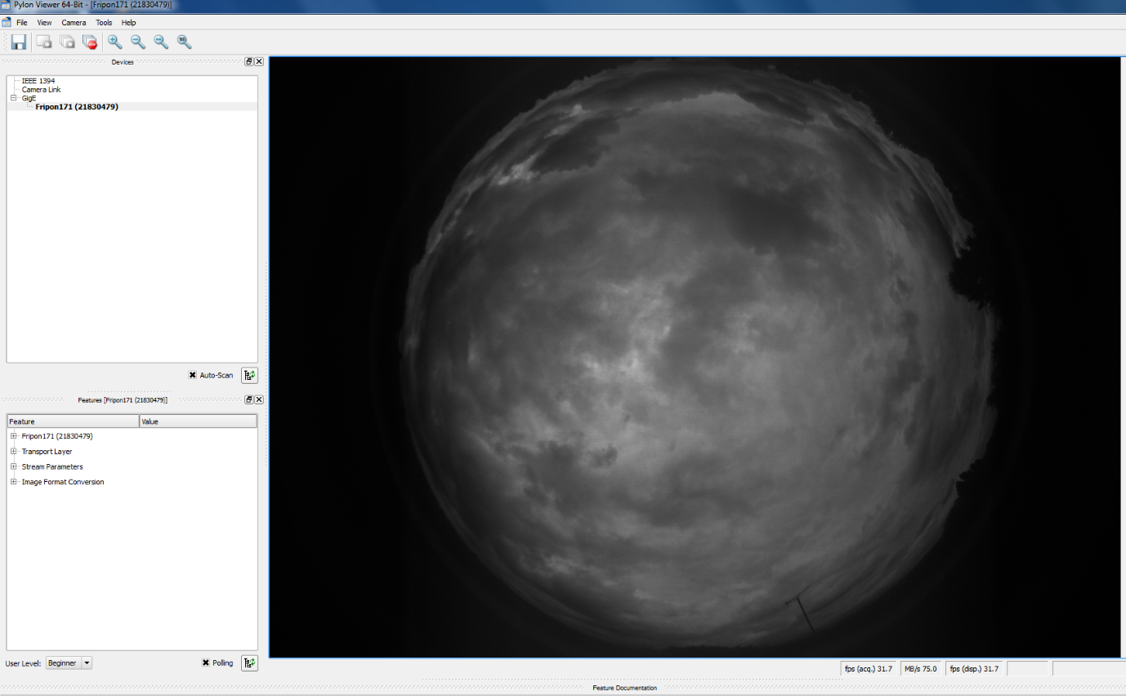Run “**pylon Viewer**”. Again a link should exist on your desktop. Wait ten seconds, and the name of your camera should show in the pane at the top left. Single click on the name of your camera then select the menu items “camera / Run continuous” and you should see an image like the one below, i.e. a fisheye image of the sky. During the day, you should have a live, clear image of the sky showing planes and clouds moving in real time. If you’re doing this at night, the image may refresh every few seconds rather than being continuous. Either is fine.

Once you have FreeTure installed you won’t need to use Pylon again, but don’t uninstall it or you’ll lose the hardware drivers.

If you can’t get an image, it may be that your firewall or virus protection software is intercepting the data and that you’ll need to change their settings manually.

# 5. Software stage 2 – FreeTure

FreeTure was written for the FRIPON project and is freely available on the Github website. A limited amount of documentation and some static help pages are also available on the website, at <https://github.com/fripon/freeture/wiki>.

FreeTure controls the camera completely, so you don’t need to run Pylon or any other programs before running FreeTure, or in conjunction with FreeTure.

## 5.1 Obtaining and installing FreeTure for Windows

Go to <https://github.com/fripon/freeture/releases> and download the latest executable file that works for Windows. As at the date of writing this, it was version 1.01, released 30 October 2015.

Installation instructions are at <https://github.com/fripon/freeture/wiki/Installing-FreeTure> under the heading “Windows systems” and it’s all pretty self-explanatory.

## 5.2 The FreeTure configuration file

FreeTure won’t run without the configuration file being set up, so after you’ve installed FreeTure look for the file called “configuration.cfg” and customise it for your latitude, longitude, elevation above mean sea level, name of your station and preferred file locations on your computer.

An example of the configuration.cfg file (for camera 171 at East Barnet in London) is included in Appendix 2, with footnotes to explain choices. More guidance can be found at <https://github.com/fripon/freeture/wiki/The-configuration-file>.

To test your configuration file, use the command line:

**FreeTure -c "C:\Program Files\freeture\configuration.cfg" -m 3**

Where you’ll need to change “C:\Program Files\freeture\configuration.cfg” so that it’s the exact location of the “configuration.cfg” file on your computer.

Once FreeTure is running properly, you’ll see a scrolling text display in a window like the one overleaf:

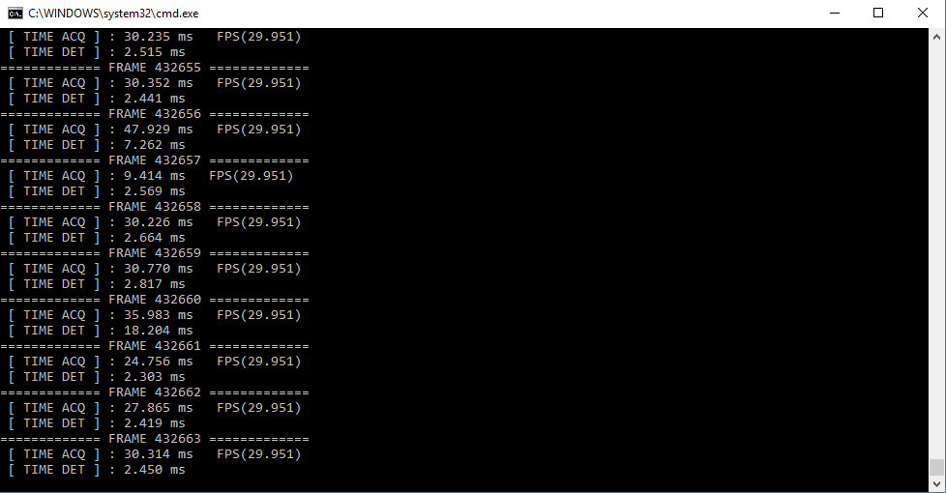

…. And that’s it. If you see this for long enough, it’s working properly. The rest of this guide is about how to get the best results and how to automate the operation of your station.

## 5.3 Network Time Protocol software

Recording when an event happened is as important as recording where it was observed from, so it’s important for your computer clock to be accurate. The best way of ensuring this is to install Network Time Protocol (NTP) software, which will poll atomic clocks over the internet and keep your computer clock very accurate. Obviously you’ll need an internet connection.

Meinberg (see <https://www.meinbergglobal.com/english/sw/ntp.htm>) produces good, free NTP software.

Set your computer clock to UTC and turn off daylight saving.

## 5.4 Creating a Mask file

A mask file defines areas which aren’t relevant to observation, and may include trees or other objects which hide the sky but which may move slightly or suddenly change in illumination and so trigger the camera. Events in black areas of the mask are ignored. It’s not essential to create one, but if you don’t, do remember to change the “mask” setting in the configuration file.

The FreeTure Github page has good advice on how to make a mask here <https://github.com/fripon/freeture/wiki/Create-a-mask>.

Here’s what the mask for the East Barnet camera looks like:



# 6. Software stage 3 –Autonomous Operation

This section describes how to make your PC turn on automatically, run FreeTure, then turn off automatically.

## 6.1 Batch file for the command line

As noted above, the command line to run FreeTure is:

**FreeTure -c "C:\Program Files\freeture\configuration.cfg" -m 3**

The simplest way to run this reliably is to create a batch file containing only this command. To do this, use “notepad” to create a text file containing the line above, then save it as (say) “FreeTureOption3.BAT”. Note the file extension – it needs to be “.BAT” not “.TXT”.

## 6.2 Auto start-up, and auto-Run of FreeTure

Access the power saving settings of your BIOS (usually done by hitting F12 during boot) and enable the auto-on feature at (say) 9pm each day. You’ll need to adjust this a few times each year. The computer will now turn on automatically at the chosen time.

Tell Windows to run your batch file (see above) every time it starts up. As the method for doing this differs between Windows versions, to work out exactly how to do this, search "add startup items windows 8" or similar, and add a shortcut to your batch file to the appropriate Windows startup directory.

## 6.3 Auto-off

Use “Task Manager”, a standard Windows program, and set it to run the command line **shutdown /s** at the required time, say 5:00 am every morning. This will turn the computer off in an orderly manner at the required time.

## 6.4 Remote Control Software

To access the computer from a remote location, install software such as TeamViewer, which is available free at [www.teamviewer.com](http://www.teamviewer.com). This allows you to quickly check that FreeTure is working properly at night without having to go to the location where the camera is installed.

# Appendix 1 – Assembling the Mount

It’s like Meccano. Use your mechanical aptitude to make it look like one of the following pictures, depending on how you plan to attach it to a solid object. Please note that most of the images in this Appendix have been taken from the French-language installation guide, written by Shelyak/FRIPON and available at: <https://www.fripon.org/IMG/pdf/dc0024f_instructions_installation_fripon-2.pdf>



Then use the U-bolts (supplied) to attach it to a standard TV aerial mount (Not supplied) or to a railing or other secure place, as below.



The camera can attach in 12 different ways to the top plate of the mount, so you should have no problem lining up the “N” on the camera to within 15 degrees of true geographic North.

The joint between the camera cable and “cable 1” should be inside the junction box, as below:



The finished installation should look like one of the following:

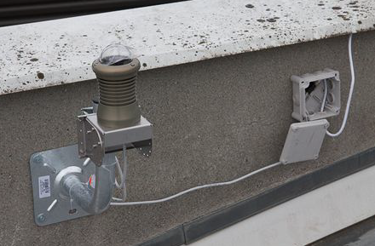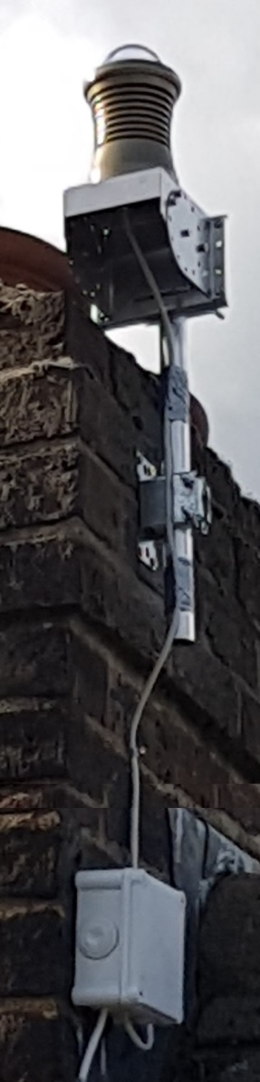

# Appendix 2 – The Configuration file

The next few pages show the configuration file (called configuration.cfg) used by FreeTure for the East Barnet station, i.e. camera 171 in London. Helpfully, all of the embedded notes and variable names are in English. Footnotes are used to highlight the bits that are either crucial, don’t work or don’t matter.

#################################################################################

########################## FreeTure Configuration file v0.6 #####################

#################################################################################

# This configuration file is mainly used by FreeTure in the mode 3.

# Use "-c" option to indicates the configuration file location to FreeTure.

# Example : freeture -m 3 -c configuration.cfg

#################################################################################

#------------------------------- CAMERA IN INPUT --------------------------------

#################################################################################

# ID number of the camera to use. (Check/find id with mode 1)

CAMERA_ID = 1[2]

# Videos location (Available if CAMERA_TYPE = VIDEO).

INPUT_VIDEO_PATH = C:\FRIPON\data_test\videos\fisheyes1.avi[3]

# Fits single frames directory location (Available if CAMERA_TYPE = FRAMES).

INPUT_FRAMES_DIRECTORY_PATH = C:\FRIPON\data_test\[4]

#################################################################################

#---------------------------- ACQUISITION PARAMETERS ----------------------------

#################################################################################

# Camera's acquisition frequency.

ACQ_FPS = 30[5]

# Camera's acquisition format. Possible values are MONO_8 / MONO_12.

ACQ_BIT_DEPTH = MONO_12

# Enable custom camera resolution : default(maximum) or 640x480

ACQ_RES_CUSTOM_SIZE = false

# Camera resolution : (width)x(height). Used if ACQ_RES_CUSTOM_SIZE = true

ACQ_RES_SIZE = 1280x960

# Enable to use a mask.

ACQ_MASK_ENABLED = true[6]

# Location of the mask.

ACQ_MASK_PATH = C:\Program Files\freeture_x64\Mask.bmp[7]

# Size of the frame buffer (in seconds).

ACQ_BUFFER_SIZE = 30

# Fix exposure time during the night (us)

ACQ_NIGHT_EXPOSURE = 33333

# Fix gain during the night.

ACQ_NIGHT_GAIN = 300

#--------------------------------------------------------------------------------

#---------------------------- DAYTIME ACQUISITION -------------------------------

#--------------------------------------------------------------------------------

# Fix exposure time during daytime (us). (Applied from end of sunrise until start of sunset)

ACQ_DAY_EXPOSURE = 20

# Fix gain during daytime. (Applied from end of sunrise until start of sunset)

ACQ_DAY_GAIN = 300

# Enable auto computation of sun ephemeris.

EPHEMERIS_ENABLED = true

# Sun horizon height (in degree) where it's the start of sunrise and the end of sunset.

SUN_HORIZON_1 = -12

# Sun horizon height (in degree) where it's the end of sunrise and the start of sunset.

SUN_HORIZON_2 = -1

# Start of sunrise (UT) if EPHEMERIS_ENABLED is disabled.

SUNRISE_TIME = 15:15

# Start of sunset (UT) if EPHEMERIS_ENABLED is disabled.

SUNSET_TIME = 21:00

# Duration of the sunset if EPHEMERIS_ENABLED is disabled.

SUNSET_DURATION = 300

# Duration of the sunrise if EPHEMERIS_ENABLED is disabled.

SUNRISE_DURATION = 100

# Time interval (seconds) between two exposure control.

EXPOSURE_CONTROL_FREQUENCY = 90[8]

# Enable to save final image with auto exposure control.

EXPOSURE_CONTROL_SAVE_IMAGE = true

# Enable to save informations in a .txt file about auto exposure control process.

EXPOSURE_CONTROL_SAVE_INFOS = true

#--------------------------------------------------------------------------------

#---------------------------- REGULAR CAPTURES ----------------------------------

#--------------------------------------------------------------------------------

# Enable regular single capture.If enabled, ACQ_SCHEDULE_ENABLED has to be disabled.

ACQ_REGULAR_ENABLED = false

# Possible values : DAY / NIGHT / DAYNIGHT

# DAY (Images are only regularly captured from start of dawn until end of twilight)

# NIGHT (Images are only regularly captured from end of twilight until start of dawn )

# DAYNIGHT (Images are always regularly captured)

ACQ_REGULAR_MODE = NIGHT[9]

# Specify the time interval of captures, exposure time, gain, format.

# Format is : .h.m.s.e.g.f.n where "." is a number)

# (h/m/s = time interval, e = exposure, g = gain, f = format, n =repetition)

ACQ_REGULAR_CFG = 00h03m30s5000e10g12f1n

# Captured image format. Possible values are JPEG / FITS

ACQ_REGULAR_OUTPUT = JPEG[10]

#--------------------------------------------------------------------------------

#---------------------------- SCHEDULED CAPTURES --------------------------------

#--------------------------------------------------------------------------------

# Enable scheduled acquisition.If enabled, ACQ_REGULAR_ENABLED has to be disabled.

ACQ_SCHEDULE_ENABLED = false

# Schedule (UT).(Format is : .h.m.s.e.g.f.n where "." is a number)

# (e = exposure, g = gain, f = format, n =repetition)

ACQ_SCHEDULE = 10h25m30s1000000e300g8f2n,

10h26m50s10000e300g12f1n

# Captured image format. Possible values are JPEG / FITS

ACQ_SCHEDULE_OUTPUT = FITS[11]

#################################################################################

#--------------------------- DETECTION PARAMETERS -------------------------------

#################################################################################

# Enable detection process.

DET_ENABLED = true

# Detection mode : DAY / NIGHT / DAYNIGHT

DET_MODE = NIGHT

# Enable debug of the detection process.

DET_DEBUG = false

# Enable to build a debug video.

DET_DEBUG_VIDEO = false

# Location of debug data.

DET_DEBUG_PATH = C:\FRIPON\freeture_test\debug\

# Time to keep before an event (seconds).

DET_TIME_BEFORE = 0

# Time to keep after an event (seconds).

DET_TIME_AFTER = 0

# Maximum duration of an event (in seconds).

DET_TIME_MAX = 20

# Choose a detection method.

DET_METHOD = TEMPORAL_MTHD

# Save fits3D in output.

DET_SAVE_FITS3D = false

# Save fits2D in output.

DET_SAVE_FITS2D = true

# Stack the event's frames.

DET_SAVE_SUM = true

# Enable histogram equalization on previous sum

DET_SAVE_SUM_WITH_HIST_EQUALIZATION = true

# Save a film .avi in output.

DET_SAVE_AVI = true[12]

# Enable auto-masking.

DET_UPDATE_MASK = false

# Enable to debug auto-masking process.

DET_DEBUG_UPDATE_MASK = true

#--------------------------------------------------------------------------------

#--------------------------------- TEMPORAL METHOD ------------------------------

#--------------------------------------------------------------------------------

# Enable to downsample (/2) frames.

DET_DOWNSAMPLE_ENABLED = true

# Save map of the global event.

DET_SAVE_GEMAP = true

# Save direction map of an event.

DET_SAVE_DIRMAP = true

# Save in a .txt file the approximate position x,y of the event.

DET_SAVE_POS = true

# Number of maximum local event.

DET_LE_MAX = 10

# Number of maximum global event.

DET_GE_MAX = 5

# Save informations about global events objects in a .txt file.

DET_SAVE_GE_INFOS = true

#################################################################################

#------------------------------- STACK PARAMETERS -------------------------------

#################################################################################

# Enable to stack frames.

STACK_ENABLED = false

# Stack mode : DAY / NIGHT / DAYNIGHT

STACK_MODE = NIGHT

# Integration time of the stack (seconds).

STACK_TIME = 60

# Time to wait before to start a new stack.

STACK_INTERVAL = 0

# Stack method : MEAN, SUM

STACK_MTHD = SUM

# Allowed dynamic reduction (Save in 16 bits instead of 32 bits)

STACK_REDUCTION = true

#################################################################################

#----------------------------- GENERAL PARAMETERS -------------------------------

#################################################################################

# Path where to save data.

DATA_PATH = C:\USERS\ADMINISTRATOR\DROPBOX\CAMERA171\FRIPONData[13]

# Path of logs files.

LOG_PATH = C:\USERS\ADMINISTRATOR\DROPBOX\CAMERA171\LOG\[14]

# Time to keep archive.

LOG_ARCHIVE_DAY = 5

# Limit size of logs on the hard disk (mo)

LOG_SIZE_LIMIT = 50

# Level of messages to save in log files : normal / notification / fail / warning / critical)

LOG_SEVERITY = notification

#--------------------------------------------------------------------------------

#---------------------------- STATION INFORMATIONS -----------------------------

#--------------------------------------------------------------------------------

# Name of the station.

STATION_NAME = NotEastBarnet[15]

# Station name.

TELESCOP = NotEastBarnet[16]

# Person in charge.

OBSERVER = charlie.brown

# Instrument name.

INSTRUME = FRIPON-171

# Camera model name.

CAMERA = BaslerAce1300-gm30

# Camera focal.

FOCAL = 1.25

# Camera aperture.

APERTURE = 2.0

# Longitude observatory.

SITELONG = -0.16921[17]

# Latitude observatory.

SITELAT = 51.63733[18]

# Elevation observatory.

SITEELEV = 87[19]

#--------------------------------------------------------------------------------

#--------------------------------- FITS KEYWORDS --------------------------------

#--------------------------------------------------------------------------------

FILTER = NONE [20]

K1 = 0.0 #R = K1 * f * sin(theta/K2)

K2 = 0.0

COMMENT = comments

CD1_1 = 0.17 #deg/pix

CD1_2 = 0.0 #deg/pix

CD2_1 = 0.0 #deg/pix

CD2_2 = -0.17 #deg/pix

XPIXEL = 3.75 #physical's size of a pixel in micro meter

YPIXEL = 3.75

#--------------------------------------------------------------------------------

#----------------------------- MAIL CONFIGURATION -------------------------------

#--------------------------------------------------------------------------------

# Allow mail notifications.

MAIL_DETECTION_ENABLED = false[21]

# SMTP server to send mail.

MAIL_SMTP_SERVER = smtp.gmail.com

# Enable or disable SMTP server authentification : NO_SECURITY / USE_SSL

MAIL_CONNECTION_TYPE = USE_SSL

# SMTP server user.

MAIL_SMTP_LOGIN = jim.rowe.temporaryaccount@gmail.com

# Password encoded in base64 (https://www.base64encode.org/). BE CAREFUL, THIS IS NOT WELL SECURED !

MAIL_SMTP_PASSWORD = c3RF44pU88867^^$pY2tlcjk5

# Recipients of mail notifications. Use "," as separators between mail adress.

MAIL_RECIPIENT = yoan.audureau@gmail.com,jimrowepermanentaccount@gmail.com

# Appendix 3 – What’s inside the camera enclosure

The FRIPON camera has a well-designed, well-made enclosure. Apart from that, it’s an assemblage of standard, easily-obtained components as below:



# Appendix 4 - Contact

Written by Jim Rowe, operator of SCAMP camera 2 which is based in East Barnet, North London, UK.

Web: <https://ukmeteornetwork.co.uk/SCAMP/>

Phone: **+44 20 7993-5580**



1. Basler “USER’S MANUAL FOR GigE CAMERAS”, document number AW00089323000, page 425.
2. Don’t change this unless you have multiple cameras.
3. Not used.
4. Not used.
5. Don’t change this. It’s the right setting for night-time operation.
6. For help on how to create a mask, see online Freeture support on Github. A mask is not essentialso this can be set to “false”.
7. If you create a mask then the path name must be correct or FreeTure will crash.
8. Every 90 seconds, FreeTure checks whether the exposure length is correct.
9. This should be “NIGHT” as the FRIPON network is currently only operated at night. Daytime operation is an objective for the future.
10. It is not clear that this input has any effect.
11. This is an astronomical format with embedded text and numerical data. A FITS viewer is available from Nasa and many other websites.
12. In the Windows version of Freeture, this input seems to be ignored.
13. This is where FreeTure is to dump observational and exposure data and must exist or FreeTure will crash.
14. This is where FreeTure is to dump log files and must exist or FreeTure will crash.
15. Choose a name.
16. Choose a name.
17. Update as accurately as possible.
18. Update as accurately as possible.
19. Elevation above Mean Sea Level, in metres. Update as accurately as possible.
20. Our working assumption is that this section is appropriate for the Basler/Focusafe setup in the current FRIPON camera. It is not yet possible to validate that assumption or discover exactly how these settings are applied.
21. Setting this to “true” will make Freeture crash every time it detects an object then tries to e-mail the data to you.